NIH Letter of Intent
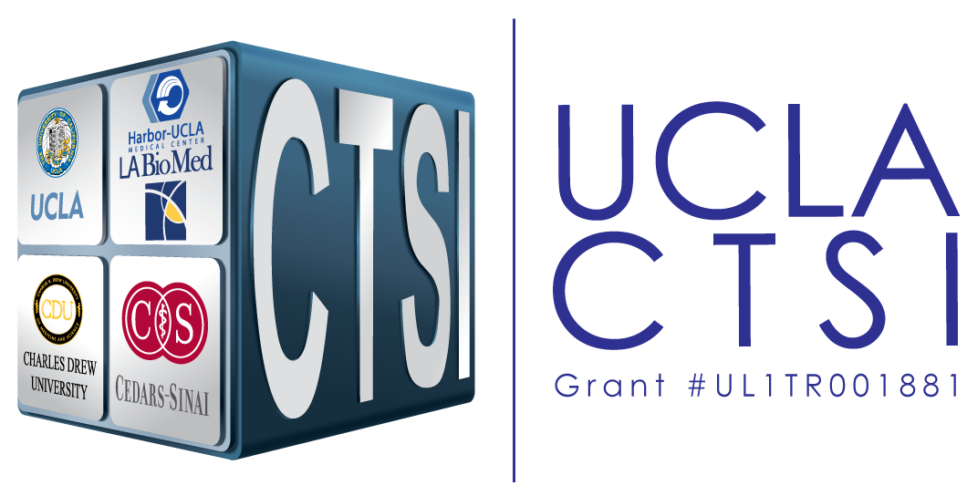

Guidelines
- Typically due 30 days prior to application due date, however usually NOT required
- Format:
  - Signed letter placed on official letterhead of PI institution/department
- Content:
  - Address all fields below
- When letter is complete:
  - Copy text onto official letterhead of Contact PI
  - Save file as “Letter of Intent” and email to Program Officer

[PUT ON OFFICIAL LETTERHEAD]
[INSERT DATE]

[INSERT PROGRAM OFFICER SIGNATURE BLOCK]

RE: RFA #: RFA TITLE:

Dr. ,

We are submitting this letter of intent to indicate our plans to submit a proposal for the above referenced RFA. The requested LOI information is listed below.

Project Title:
Participating Institution(s):

The Contact Principal Investigator is:
NAME, Title, Institution. Address; Phone Number.

The Multi‐PI(s) on this proposal is:
NAME, Title, Institution.

Additional Key Personnel will be:
Name, Title, Institution.
Name, Title, Institution.
Name, Title, Institution.
Name, Title, Institution.
Name, Title, Institution.

OPTIONAL: 1 Paragraph about goals/aims/relevance to funding agency.

Sincerely,

[INSERT SIGNATURE BLOCK OF CONTACT PI]

