NSF Project Summary Guidelines
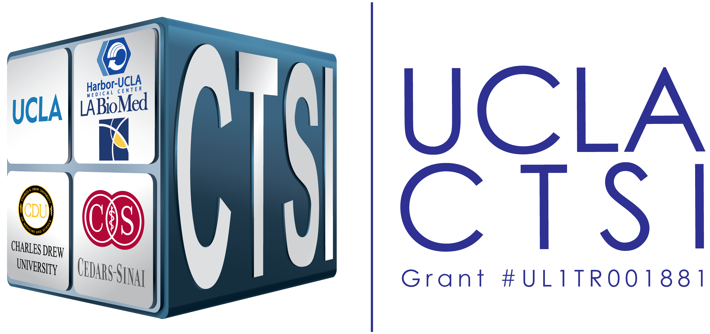
Guidelines
- Format:
  - Page Limit: 1 pg. max.
  - Margins min. 1”
  - NSF-allowable fonts:
    - Arial, Courier New, or Palatino Linotype; font size min. 10 pts
    - Times New Roman; font size min. 11 pts
    - Computer Modern family fonts; font size min. 11 pts
- Content:
  - The Project Summary consists of:
    - Overview
    - Intellectual Merit
    - Broader Impacts
  - The Project Summary should be informative to other persons working in the same or related fields, and, insofar as possible, understandable to a broad audience within the scientific domain. It should not be an abstract of the proposal.
- When form is complete:
  - Remove this box
  - Save file as “Project Summary”

Overview
The overview should discuss long-term objectives, the aims that support these objectives, and the methodology researchers will employ to achieve them. The overview is the introduction that illustrates the importance of the project in terms of its effect and impact.
Intellectual Merit
This section should address what is currently known and, more importantly, what is not known in the field. Researchers should show how the proposal will fill an important gap in existing knowledge, and how the proposed activities will advance knowledge across scientific fields in creative and transformative ways. PI qualifications and institutional resources should also be described.
Broader Impacts
The Broader Impacts statement is an important part of the Summary Page and will heavily affect the chances of being funded. This section is about promoting teaching, training, research and learning, while also advancing the participation of underrepresented groups. A description of how science and technology will be enhanced by the project, as well as its broad societal impacts, should be included.

